Android Firebase Notifications:

GCM was deprecated, instead they have introduced Firebase cloud messaging service.

For the whole set up I followed a YouTube video which referred to the firebase website docs on how to add FCM to your android Studio project

The YouTube link is below:

<https://www.youtube.com/watch?v=uuiuVDb2bug>

And the official docs for Firebase set up on android studio:

<https://firebase.google.com/docs/android/setup> or search for Add Firebase to your Android project

Even after doing that I faced few errors and issues for which I referred to few github codes and one of them which had most accurate fixes were from

<https://firebase.google.com/docs/cloud-messaging/android/client>

<https://github.com/ton1n8o/FCMTutorial>

<https://github.com/firebase/quickstart-android/blob/master/messaging/>

If you know Java or worked on android studio set up it will be quicker.

Steps (brief to decide on time-for setup of FCM refer official docs):

* Set up firebase by making required changes in the source code of your project:
  + Add plugin code to build.gradle
  + Change manifest code according the docs
  + Add new java file ->MyFirebaseMessagingService.java
  + Copy paste to your project google-services.json
  + Make sure your device has enabled google-services API
* Create a project in FCM
  + Go to cloud messaging extension
  + New notification select which app
  + Publish. It gets broadcasted to all devices running the app in the background

Few screenshots of the broadcast messages:

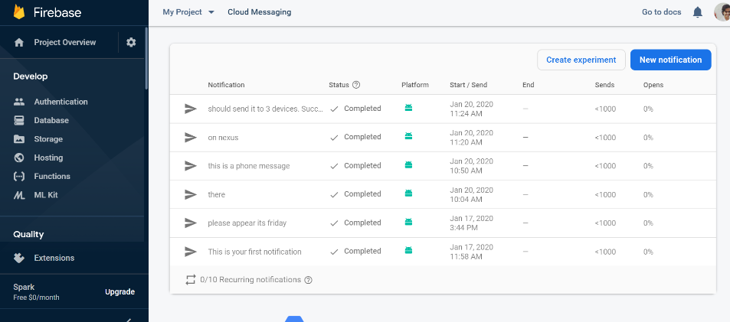

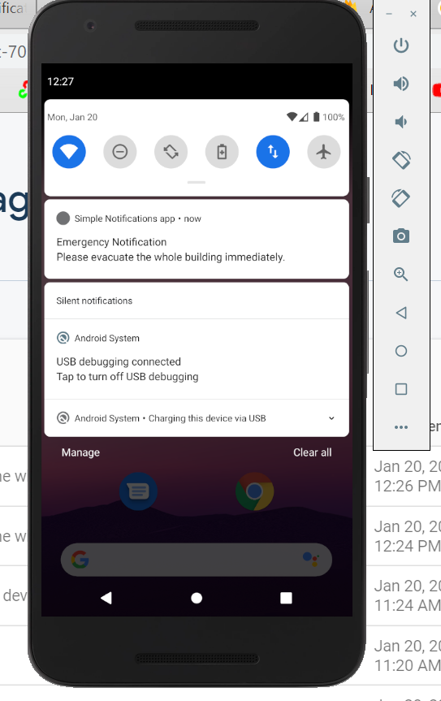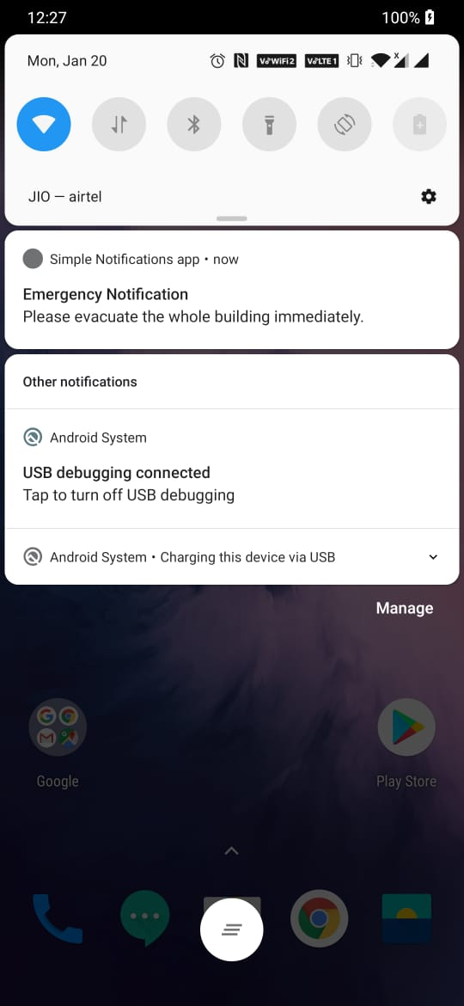

Emulator Phone